Profit and Loss for a particular product
Objective:
To find the Profit and Loss for a particular product.
Complexity level:
- Easy
Business Scenario:
- A retail vendor manages a shop name ABC & co. The procurement manager will manages suppliers and develop purchasing strategies which meet budgetary and other operational requirements of the shop. The buyer purchase the grocery items from the wholesale market and sales them in the retail market. He buys the items on a daily basis and sells them to the retail market same day.
- There are situation where all items cannot be sold, can be carrying to next day only (otherwise it has to be junked. The items cannot be carrying forward. (Buying day + one day).
- Stock can only be sold after it is bought.
Data set:
(Price numbers are in US Dollars)
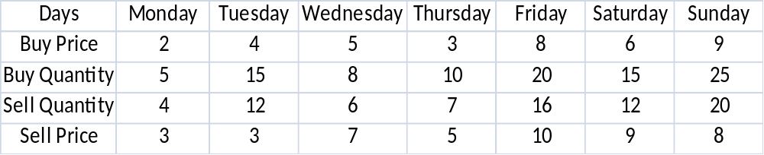
Problem Statement:
- Write an algorithm to find the profit/loss on the above data.

Expectation Outcome:
Draw the flow chart or write the pseudo code to find out the profit or loss.
Tools:
- Open office for designing the flow chart.
Reference URL:
- Professional English in Use - Finance, Cambridge University Press, p. 10.
- Helfert, Erich A. (2001). "The Nature of Financial Statements: The Income Statement". Financial Analysis - Tools and Techniques - A Guide for Managers. McGraw-Hill. p. 40. doi:10.1036/0071395415 .
- Warren, Carl (2008). Survey of Accounting. Cincinnati: South-Western College Pub. pp. 128–132. ISBN 978-0-324-65826-2 .

